1. Basic Linux commands
- ls – lists all the directories and files available in the current working directory.
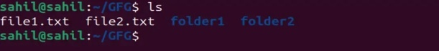
- pwd – used to display the full path of the current directory
- mkdir – used to create new directories or folders.
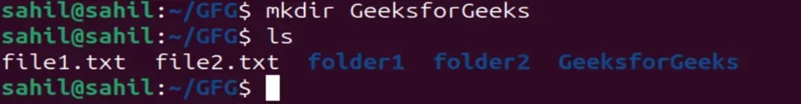
- cd – change the current working directory.
- rmdir – used to delete empty directories.
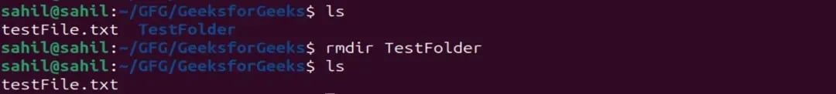
- cat – used to display file contents and combine multiple files.
- cp – used to copy files or directories.
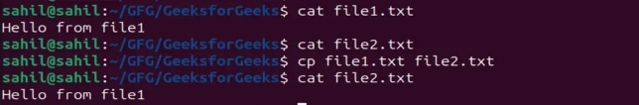
- mv – used to move or rename files and directories.
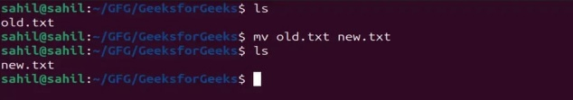
- rm – used to delete files permanently.
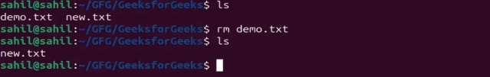
- uname – used to display system information.

2. Basic Git Commands
- git init – creates a new repo
- git clone <url> - copies an existing repo.
- git add . – add all files and changes.
- git status – it checks your recent added.
- git commit -m “message” – save changes and adds a message.
- git checkout – switch branches.
- git branch – display list of existing branches.
- git push – uploads the save code to a repo
- git pull – fetch and merge save code to the current branch.
- git merge – combine branches into a single branch.

3. Three-tree architecture of Git

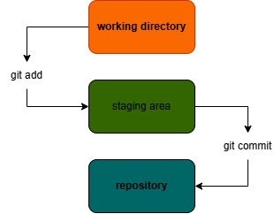

REFERENCES:

Basic-linux-commands – https://www.geeksforgeeks.org/linux-unix/basic-linux-commands/

Git-cheat-sheet – https://git-scm.com/cheat-sheet

Git-three-stage-architecture –
https://prakhar09.hashnode.dev/git-three-stage-architecture https://prakhar09.hashnode.dev/git-three-stage-architecture

REMINDER!

I have not used any AI or AI-assisted technologies to prepare this work.

